UD Nanofabrication Facility (UDNF)
https://udnf.udel.edu/capabilities/

Film Casting
Type | Make | Model | UD Fee | Ext. Academic Fee | Corporate Fee | Notes
E-beam SBU1 | Brewer Science | CEE 200CBX | $0/hr | $0/hr | $0/hr | Spin-Bake Unit
E-beam SBU2 | Brewer Science | CEE 200CBX | $0/hr | $0/hr | $0/hr | Spin-Bake Unit
Photo SBU1 | Brewer Science | CEE 200CBX | $0/hr | $0/hr | $0/hr | Spin-Bake Unit
Photo SBU2 | Brewer Science | CEE 200CBX | $0/hr | $0/hr | $0/hr | Spin-Bake Unit
SU-8 SBU | Brewer Science | CEE 200CBX | $0/hr | $0/hr | $0/hr | Spin-Bake Unit

Lithography
Type | Make | Model | UD Fee | Ext. Academic Fee | Corporate Fee | Notes
E-beam Writer | Vistec | EBPG5200ES | $80/hr | $120/hr | $225/hr
Laser Writer | Heidelberg | MLA 100 | $30/hr | $45/hr | $100/hr
Mask Aligner | NXQ | NXQ8006 | $20/hr | $30/hr | $75/hr

Deposition
Type | Make | Model | UD Fee | Ext. Academic Fee | Corporate Fee | Notes
ALD | Oxford Instruments | FlexAL | $50/hr | $75/hr | $150/hr
Evaporator 1 | PVD Products |  | $30/hr | $45/hr | $100/hr | Approved materials
Evaporator 2 | PVD Products |  | $20/hr | $45/hr | $100/hr | Approved materials
PECVD | Plasma-Therm | Versaline | $30/hr | $45/hr | $100/hr
PLD | PVD Products | PLD-4000 | $50/hr | $75/hr | $150/hr | Approved materials
Sputterer | PVD Products |  | $30/hr | $45/hr | $100/hr | Approved materials

Dry Etch
Type | Make | Model | UD Fee | Ext. Academic Fee | Corporate Fee | Notes
Asher | Branson/IPC | 3000 | $20/hr | $30/hr | $75/hr
Chlorine ICP | Plasma-Therm | Apex SLR | $30/hr | $45/hr | $100/hr
Fluorine ICP | Plasma-Therm | Apex SLR | $30/hr | $45/hr | $100/hr
Ion Mill | IntlVAC | Nanoquest | $30/hr | $45/hr | $100/hr
Plasma cleaner | Harrick Plasma | PDC-001 | $20/hr | $30/hr | $75/hr

Thermal Processing
Type | Make | Model | UD Fee | Ext. Academic Fee | Corporate Fee | Notes
HMDS Oven | Yield Engineering | YES-310TA | $0/hr | $0/hr | $0/hr
Rapid Thermal Processor | Surface Science Integration | Solaris 150 | $20/hr | $30/hr | $75/hr
Tube Furnace | Expertech | CTR-125 | $20/hr | $30/hr | $75/hr
Vacuum Ovens | Thermo Scientific | VT 6060 | $0/hr | $0/hr | $0/hr

Metrology
Type | Make | Model | UD Fee | Ext. Academic Fee | Corporate Fee | Notes
Ellipsometer | Woolam | M-2000 | $0/hr | $0/hr | $0/hr
Four-Point Probe Station | Jandel | MWP-6 | $0/hr | $0/hr | $0/hr
Microsopes | Zeiss | Axio Imager | $0/hr | $0/hr | $0/hr | Shuttle & Find for integration with the FE-SEM
Profilometer | Bruker | Dektak | $0/hr | $0/hr | $0/hr | Includes film stress measurement capabilities
SEM | Zeiss | Merlin | $20/hr | $30/hr | $75/hr

Packaging
Type | Make | Model | UD Fee | Ext. Academic Fee | Corporate Fee | Notes
Dicing Saw | ADT | 7122 | $20/hr | $30/hr | $75/hr | Located outside cleanroom
Wire Bonder | TPT | HB05 | $20/hr | $30/hr | $75/hr | Located outside cleanroom

Miscellaneous
Type | Make | Model | UD Fee | Ext. Academic Fee | Corporate Fee | Notes
Critical Point Dryer | Tousimis | Autosamdri-815, Series B | $20/hr | $30/hr | $75/hr
Developing Station | Brewer Science | CEE 200XD | $0/hr | $0/hr | $0/hr
Mask Cleaner Station | Brewer Science | CEE 200XD | $0/hr | $0/hr | $0/hr
Ozone Cleaner | Novascan | PSD-UV8 | $20/hr | $30/hr | $75/hr
Wet Benches (15) | Air Control | varies | $0/hr | $0/hr | $0/hr

Keck Center for Advanced Microscopy and Microanalysis
https://www.camm.udel.edu/instruments/
The JEM-2010F FasTEM provides 1.9 Å point resolution and 1.0 Å lattice resolution with an information limit of 0.75 Å. A few peripheral attachments further enhance its analytical capabilities; these include the scanning transmission electron microscopy (STEM) for both bright field (STEM-BF) imaging and high angle annular dark field (STEM-HAADF) imaging, electron energy loss spectroscopy (EELS) and energy filtered imaging, and X-ray energy dispersive spectroscopy (XEDS). In addition, this instrument allows remote access and remote control through internet connection.
In addition to conventional imaging and diffraction, the Tecnai G² 12 Twin TEM is facilitated with cryo-TEM and low dose imaging capabilities.
The JSM-7400F field emission scanning electron microscope has a 1 nm resolution at 15 kV and a 1.5 nm resolution at 1 kV. It allows operation in a wide range of beam energies from 0.1 keV to 30 keV, and affords various operation modes, including secondary electron imaging (SEI), backscattered electron imaging, gentle beam mode, and imaging with energy filters. An ultrathin window energy-dispersive X-ray spectroscopy (XEDS) detector identifies elements of an atomic number greater than four, and offers a 130 eV spectral resolution. This SEM also allows remote control via the internet.
The AURIGATM 60 CrossbeamTM FIB-SEM provides high resolution solutions for nano-tomography, 3-D imaging and analysis, lamellar and thin foil preparation, and nano-patterning. In conjunction with an Axio Imager M2 light microscope, a “Shuttle & Find” correlative microscopy scheme allows the visible light contrasts and information about feature color, size, and morphology obtained by the light microscope to be combined with advanced analytical methods of the AURIGATM 60 electron and ion optics for the discovery of new structural and elemental information. Additionally, the view-and-slicing capability of the FIB-SEM extends the opportunities to correlative tomography. The high resolution FIB optics of AURIGATM 60, together with its high precision stage, also enables nano-scale patterning or fiducial mark preparation, which can further facilitate other correlative analyses, such as those offered by vibrational spectroscopy.
The Keck Center has over 14 different TEM sample holders, including routine single and double tilt holders, low-background analytical holders, liquid nitrogen cryo-holders and cryo-transfer holders, Protochips Aduro 300 heating & electric holder and Poseidon 500 electrochemical holder, and a Hysitron PI 95 Picoindenter. We have a variety of sample preparation equipment, including 3 ultra-microtomes with cryo-microtomy capabilities, 2 Vitrobot® stations for TEM sample vitrification and cryo-transfer, dimple devices, ion mills (including a PIPS), sputter coaters, carbon coaters, and a low speed diamond saw.
In addition, the facility houses two scanning probe microscopes (SPM) with atomic force microscopy (AFM) systems: a general purpose NanoScope V AFM and a Dimension-3100 V SPM system. The Dimension SPM includes 1) NanoMan-VS Nanolithography Software and User Interface that enables manipulation and lithography at the nanometer and molecular scale, 2) TUNA module for electric measurement, and 3) Real-time HarmoniX that measures variations in material properties during Tapping-Mode Imaging to provide independent nanometer scale images of peak force, adhesion, stiffness, dissipation, and average force.

Advanced Materials Characterization Lab
https://sites.udel.edu/amcl/

Mass Spec & Chemical Analysis

Metrohm IC Pro

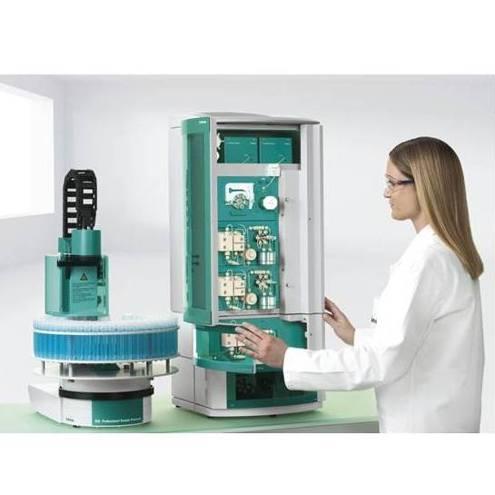
- Anions, cations and ancat dual systems
- Anion systems with or without suppression
- Chemical suppression followed by CO2 suppression (sequential suppression)
- Sequential suppression with inline ultrafiltration or dialysis (Prep1)
- Sequential suppression with inline pre-concentration
- Inline matrix elimination or inline calibration (Prep 2)
- Sequential suppression with inline neutralization and inline cation removal (Prep 3)
- Low pressure or high pressure gradient

CNHS Elementar Cube
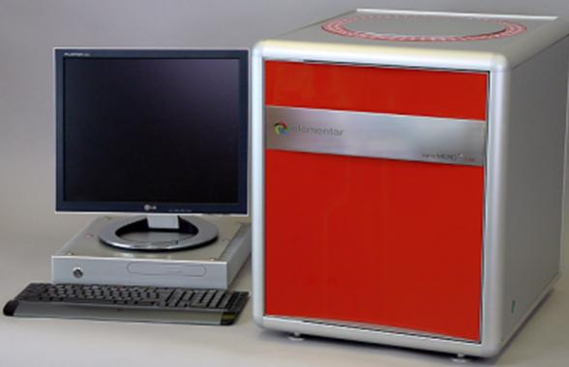
The modern “cube” platform is setting the standards for elemental analyzers. Outstanding instrument design and intelligent engineering in combination with 110 years experience in the development of elemental micro-analyzers lead to unmatched precision of your analysis. Less than 1 mg pharmaceuticals can be analyzed just as precise as 500 mg soil samples.
Total ratios of Carbon , Nitrogen, Hydrogen and Sulfur capable.

Agilent 7500 ICP/MS
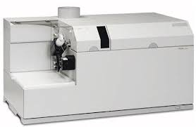
CP-MS is widely acknowledged as the premier technique for trace metals analysis.Today’s routine lab requires much greater sensitivity than is provided by ICP-OES, and far higher sample throughput than sensitive, but slow GFAA. ICP-MS meets both these requirements, over a wider analytical working range, and is capable of simultaneously measuring the hydride elements and trace Hg, while adding semiquantitative and isotopic analysis capabilities. ICP-MS is also an extremely powerful and versatile detector for chromatography and laser applications.

Thermo Fisher ICAP/TQ
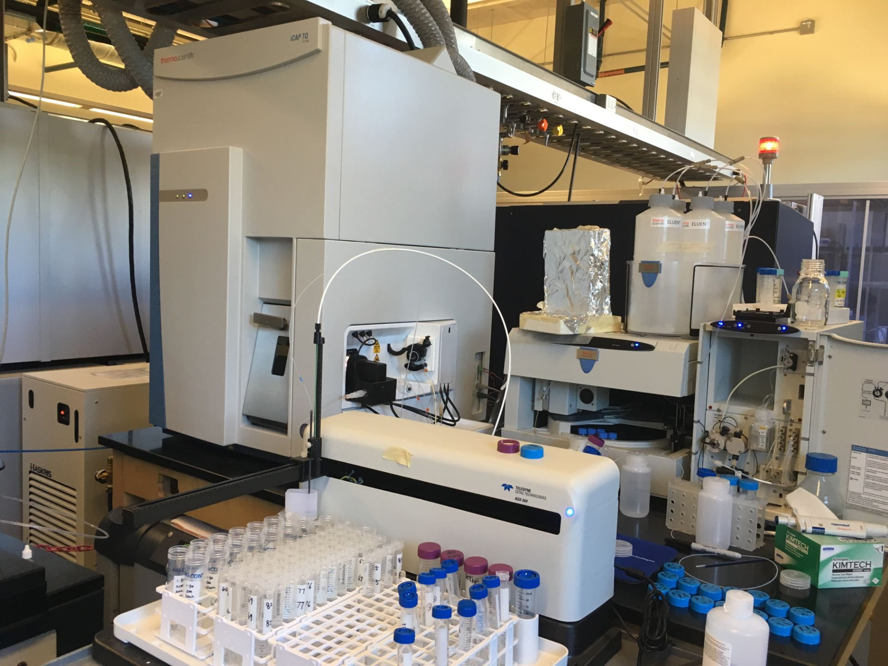
Delivering research level trace elemental analysis, combined with routine ease-of-use, the Thermo Scientific™ iCAP™ TQ ICP-MS is a high-performance, future-proof ICP-MS solution. Harness the power of Triple Quadropole (TQ) technology for uncomplicated analysis with incredible accuracy. Expand your applications and enhance your laboratory efficiency with breakthrough triple quadrupole technology that is so easy to use, any analyst can operate it.

Porosity, Zeta Potential and Particle Size

Wyatt Mobius DLS Zeta Potential
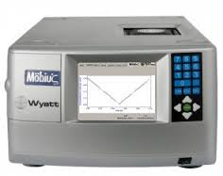
Wyatt Technology has developed an MP-PALS (massively parallel phase analysis light scattering) instrument for measurement of the electrophorectic mobility and determination of zeta potential (electrokinetic potential) of not only large particles, but also to measure protein samples including antibody formulations, bovine serum albumin and lysozyme, all down to 1 nm.
http://www.wyatt.com

Micromertics ASAP 2020 BET Analyzer
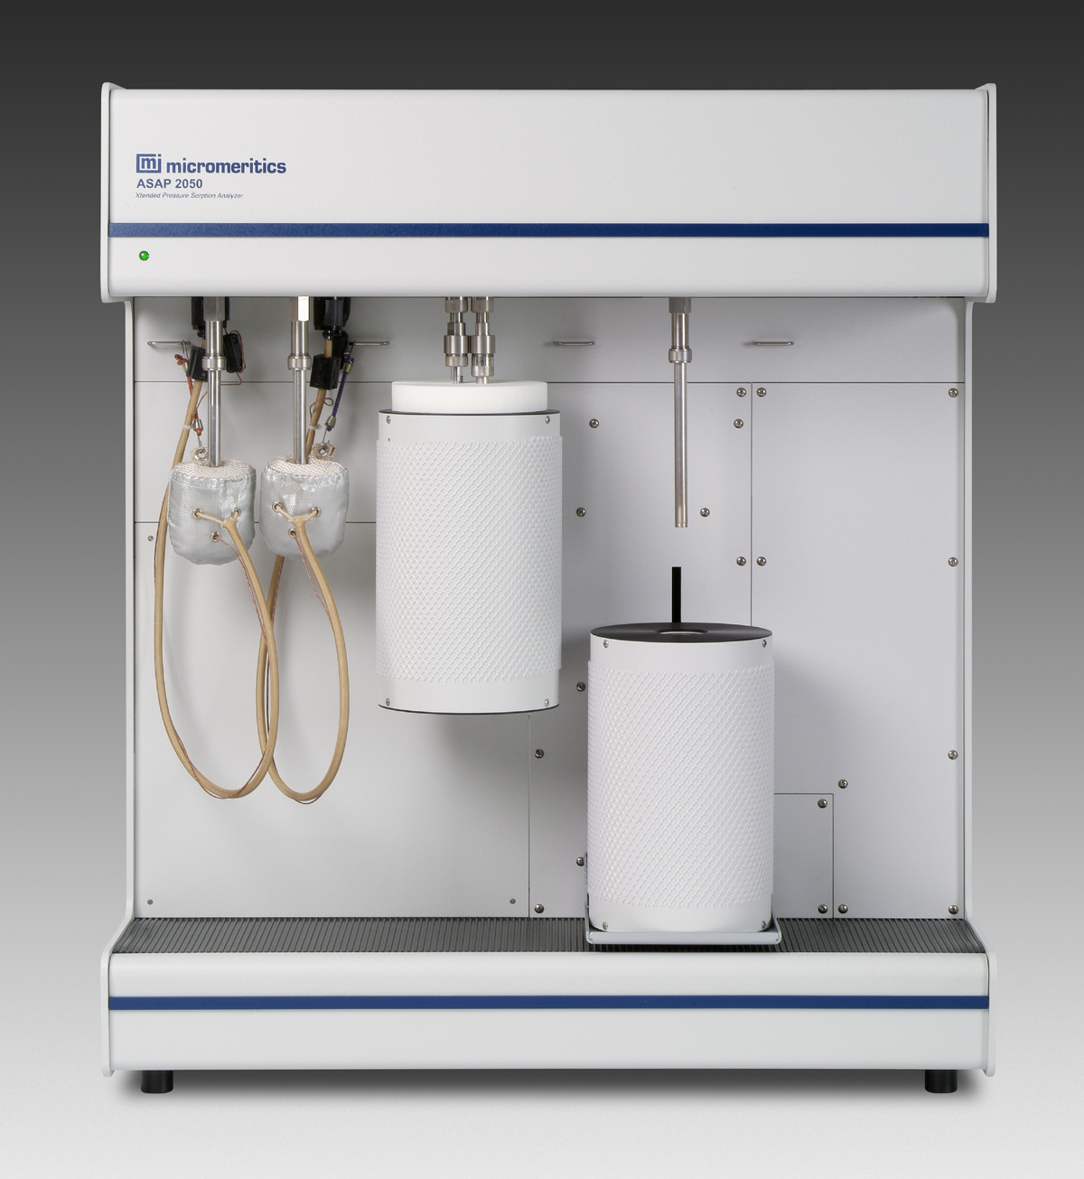

Accurate and precise surface area and porosimetry measurements are essential to the determination of the effectiveness and quality of a wide variety of materials. The Micromeritics ASAP 2020 integrates multiple gas sorption techniques into a single, convenient table top instrument.

Beckman Coulter LS 13 320 Particle Size Analyzer
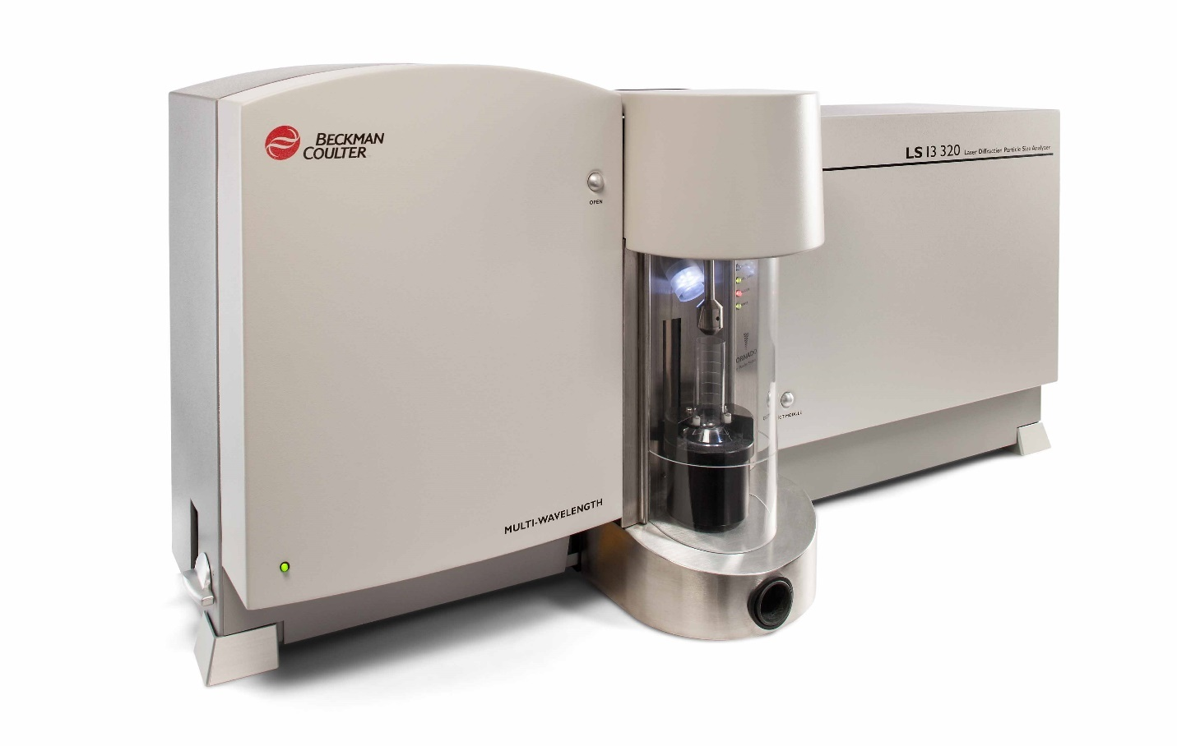
The LS 13 320 MW is one of the most versatile and sophisticated laser diffraction particle size analyzers available today. Using the Fraunhofer and Mie theories of light scattering, the LS 13 320 MW offers the highest resolution, reproducibility and unsurpassed accuracy. Its state-of-the-art, laser-based technology permits analysis of particles without the risk of missing either the largest or the smallest particles in a sample.

VCA Optima Contact Angle
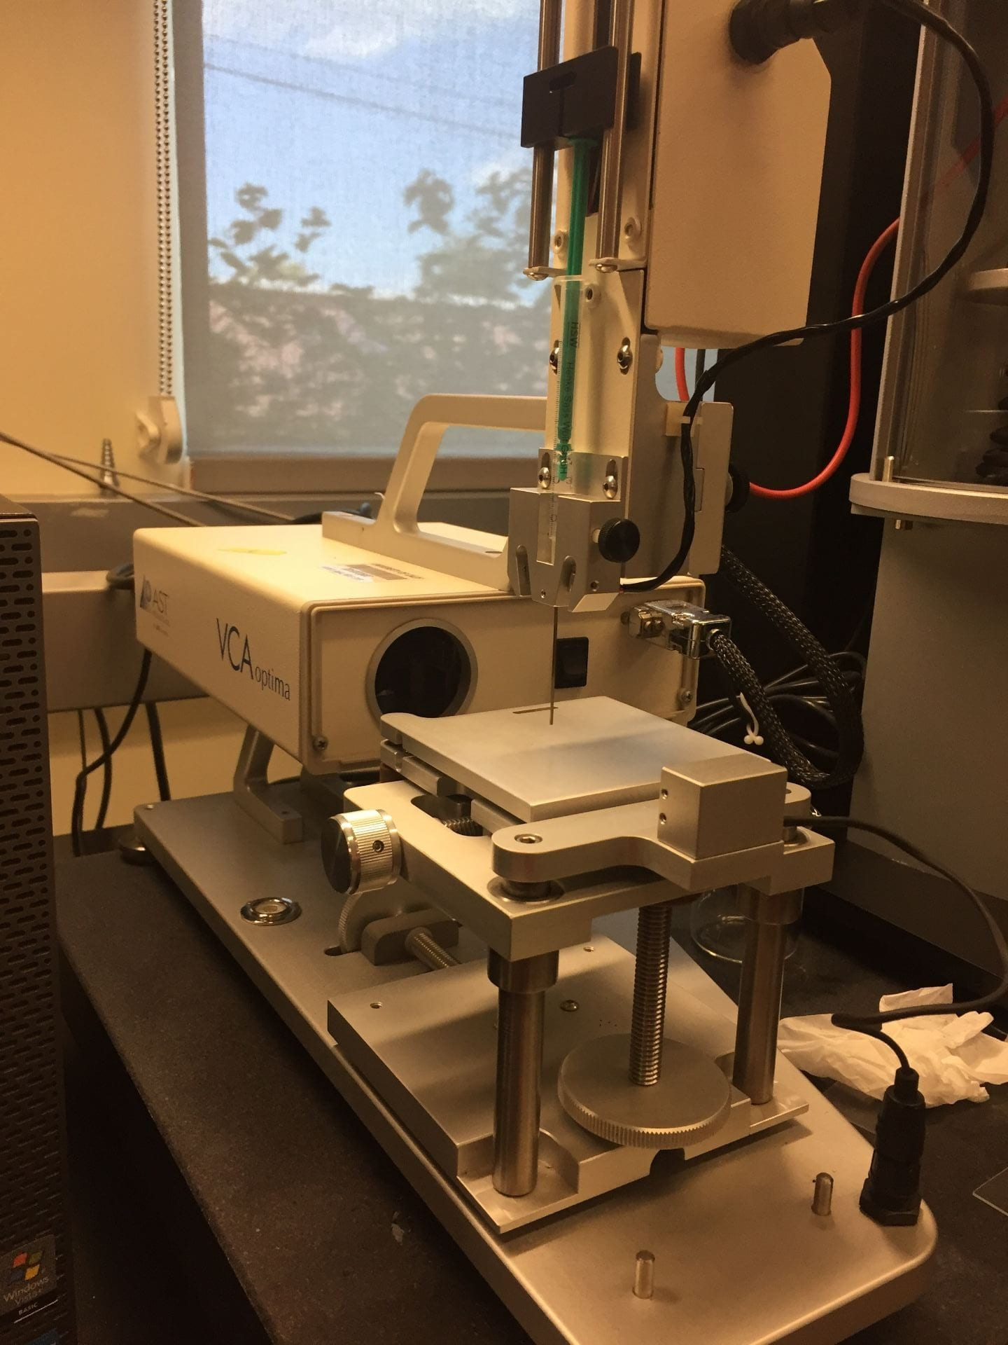

The VCA Optima utilizes a precision camera and advanced PC technology to capture static or dynamic images of the droplet and determine tangent lines for the basis of contact angle measurement. A manual syringe provides easy dispensing of test liquid.

Sigma 700 Surface Tension
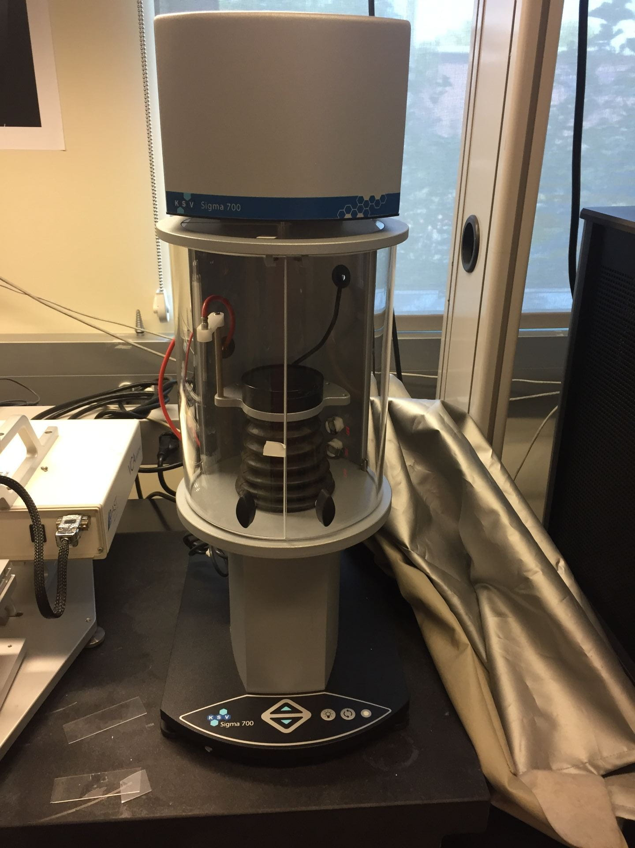
The Sigma 700 force tensiometers are able to perform a wide range of measurements and adapt to a great variety of experimental settings. A temperature cell can be used to cool or heat samples.

Vibrational

Anasys Nano IR2
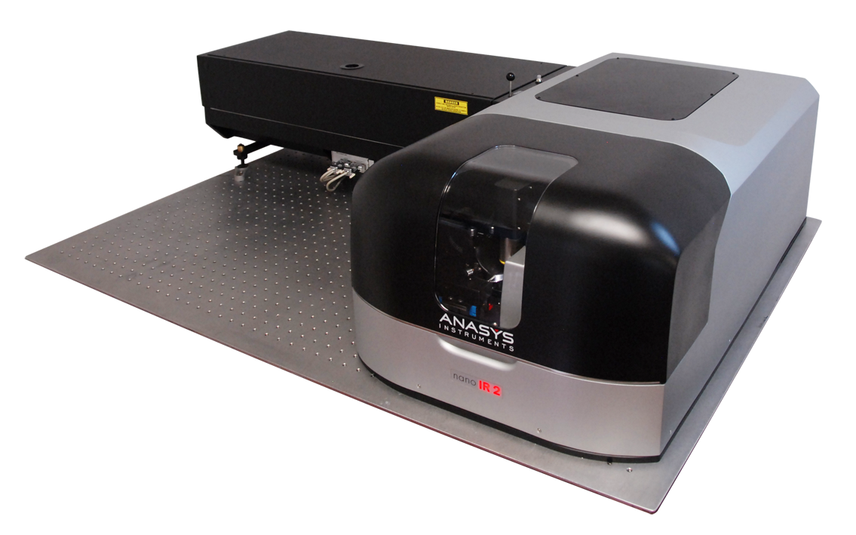
Expands nanoscale IR to a broad range of real world samples.
New resonance enhanced mode enables nanoscale IR on <20nm films.
Rich, interpretable IR spectra.
Powerful, full featured AFM.
Multifunctional measurements including integrated thermal and mechanical property mapping.
Designed and built for productivity and rapid time-to-results.

FTIR
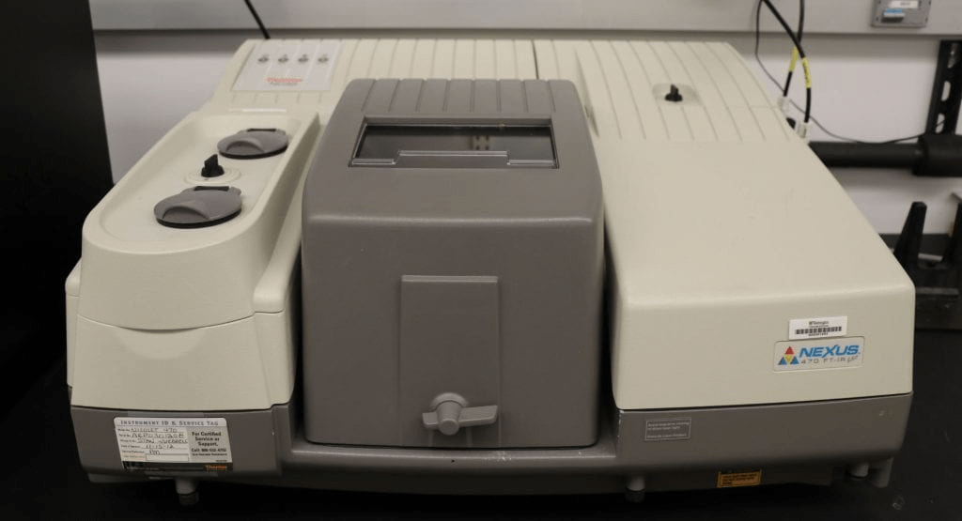

ATR

Raman Spectrometer
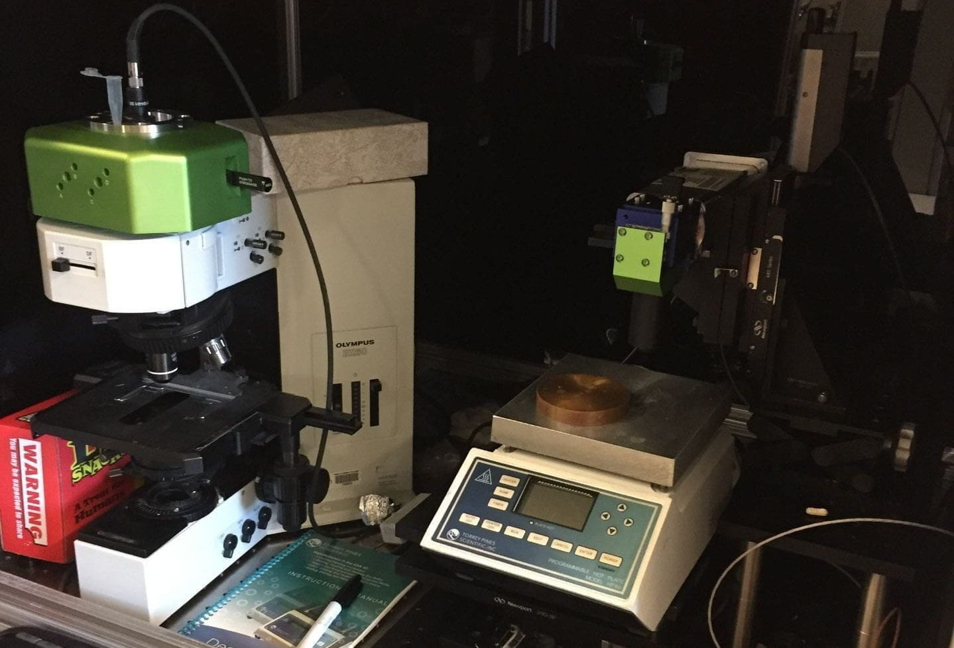

neaSNOM Microscope
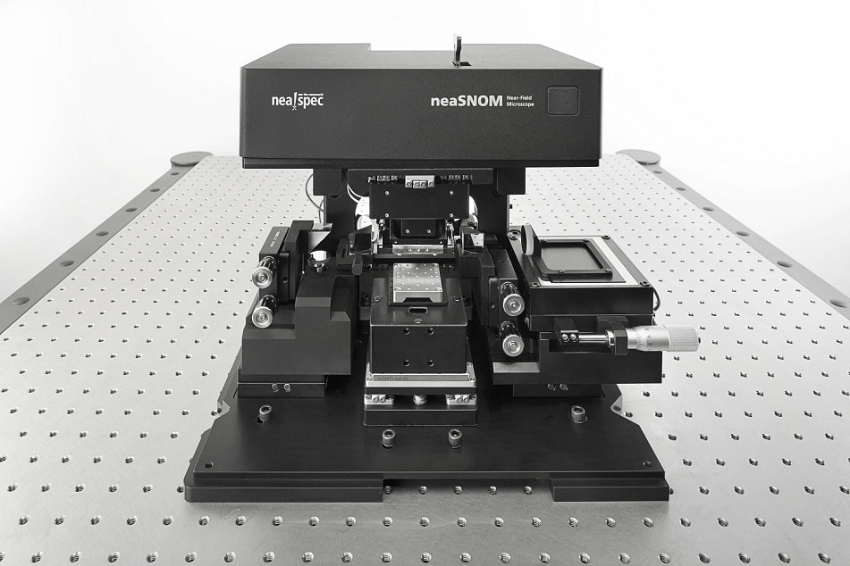

Thermal Analysis

TA DTC 300
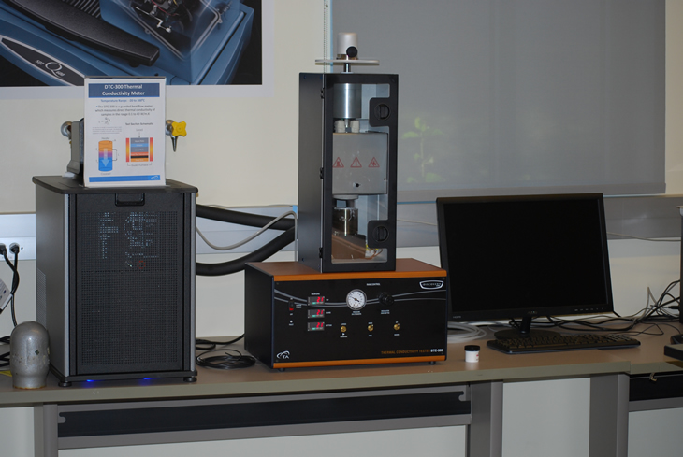
The DTC-300 measures thermal conductivity of a variety of materials, including polymers, ceramics, composites, glasses, rubbers, some metals, and other materials of low to medium thermal conductivity. Only a relatively small test specimen is required. Non-solids, such as pastes or liquids, can be tested using special containers. Thin films can also be tested accurately using a multi-layer technique. The tests are in accordance with the ASTM E1530 Standard.

TA Q800 DMA
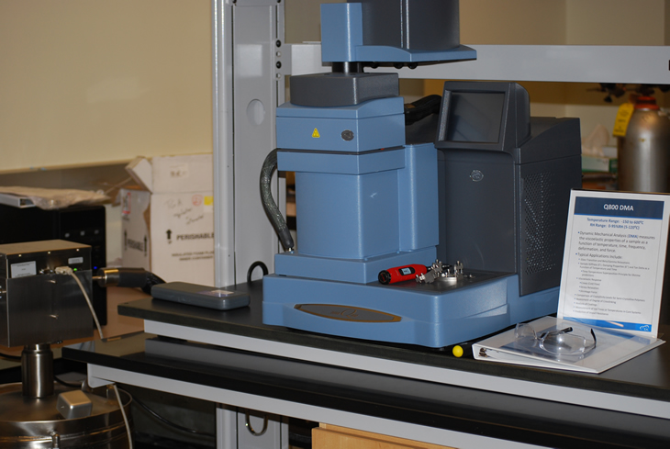
Provides both time- and frequency-domain mechanical analysis of materials. A moderate force load can be applied to the test specimen in various deformation geometries, such as tension, shear, compression, and bending. Force loading: 0.001 to 18 Newton | Deformation resolution: 1 nanometer | Frequency range: 0.01 to 200 Hz | Temperature range: -145 to 600°C | Test atmosphere: controlled inert gas or air flow

TA Q600 HT TGA/DSC
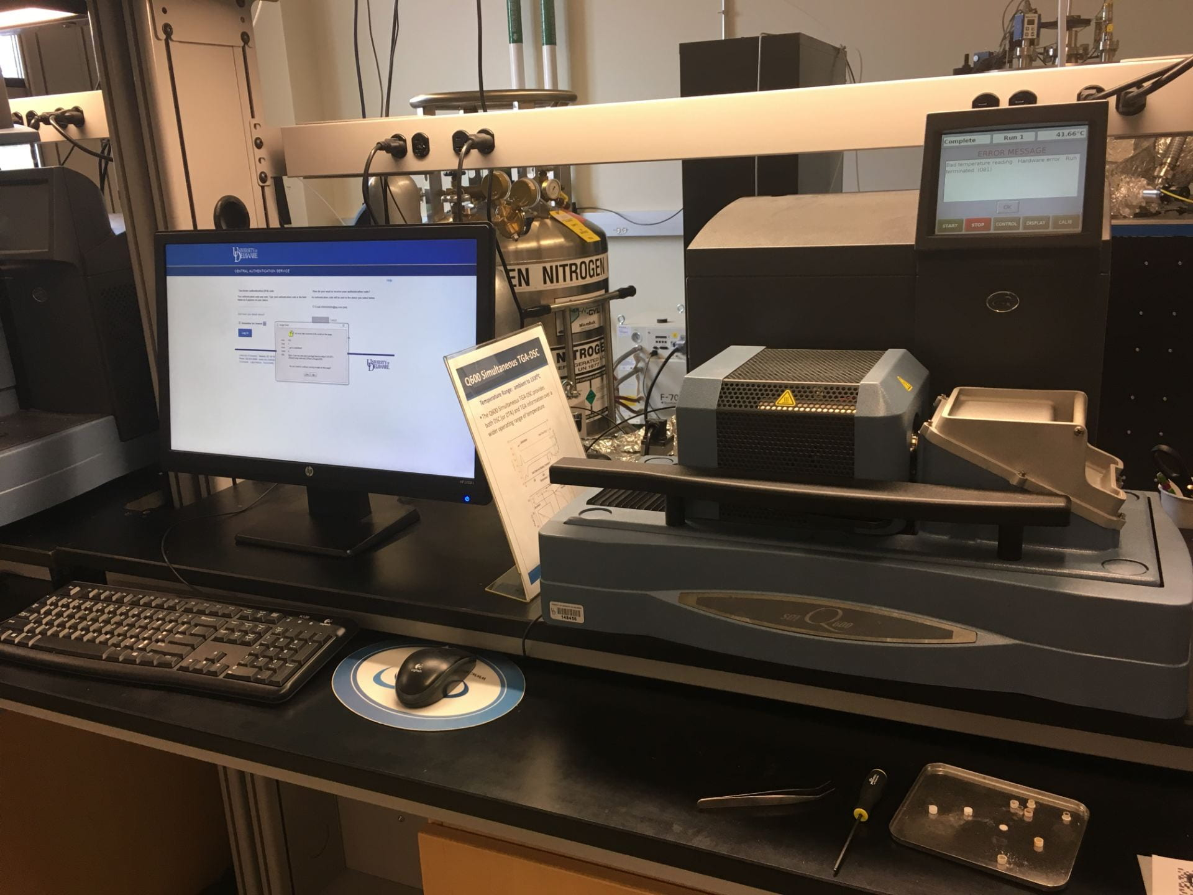
Provides both time- and frequency-domain mechanical analysis of materials. A moderate force load can be applied to the test specimen in various deformation geometries, such as tension, shear, compression, and bending. Force loading: 0.001 to 18 Newton | Deformation resolution: 1 nanometer | Frequency range: 0.01 to 200 Hz | Temperature range: -145 to 600°C | Test atmosphere: controlled inert gas or air flow

Discovery DSC
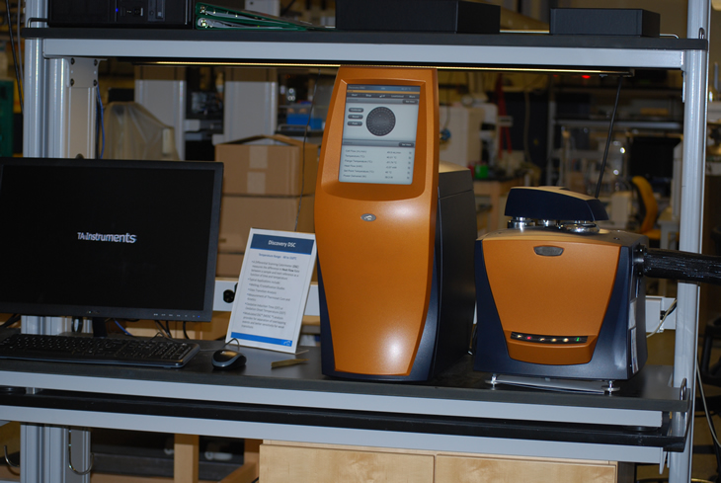
Differential scanning calorimetry or DSC is a thermoanalytical technique in which the difference in the amount of heat required to increase the temperature of a sample and reference is measured as a function of temperature. Both the sample and reference are maintained at nearly the same temperature throughout the experiment. Generally, the temperature program for a DSC analysis is designed such that the sample holder temperature increases linearly as a function of time. The reference sample should have a well-defined heat capacity over the range of temperatures to be scanned.

Discovery TGA
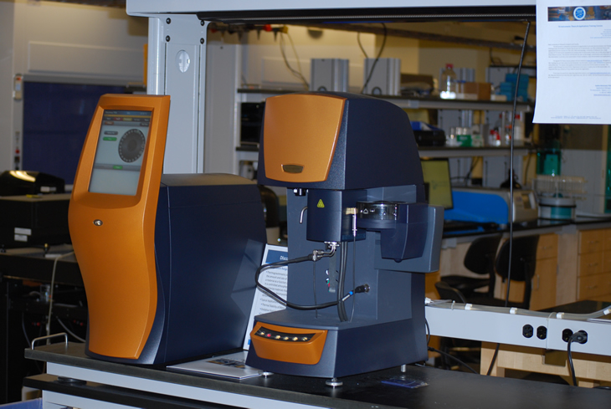
Thermogravimetric analysis or thermal gravimetric analysis (TGA) is a method of thermal analysis in which changes in physical and chemical properties of materials are measured as a function of increasing temperature (with constant heating rate), or as a function of time (with constant temperature and/or constant mass loss).TGA can provide information about physical phenomena, such as second-order phase transitions, including vaporization, sublimation, absorption, adsorption, and desorption. Likewise, TGA can provide information about chemical phenomena including chemisorptions, desolvation (especially dehydration), decomposition, and solid-gas reactions (e.g., oxidation or reduction).

X-Ray Analysis

Bruker D8 XRD
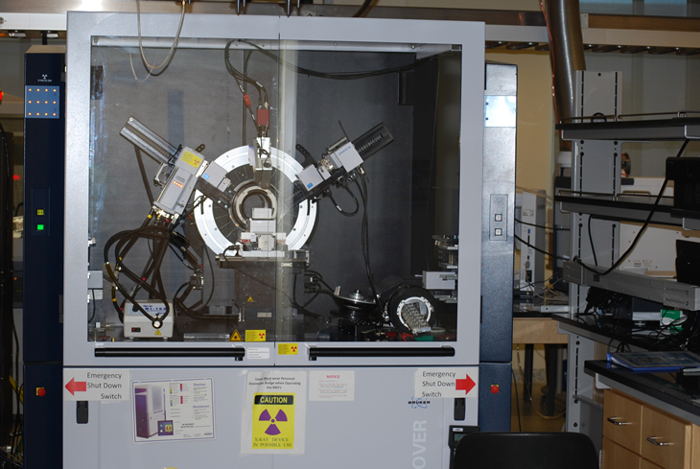
This is a versatile, sensitive, and high resolution X-Ray powder diffractometer. The monochromatic Cu Kα1 line is isolated by the Vario monochromater at the X-Ray tube. No more need to numerically subtract out the Kα2 from your data. A variety of sample holders and sample presentation methods are listed below. A LynxEye position sensitive detector permits up to 4 ° 2θ of diffracted beam to be measured continuously while scanning, which dramatically increases sensitivity compared with the conventional scintillation detector behind a narrow slit.

Rigaku Ultima IV XRD
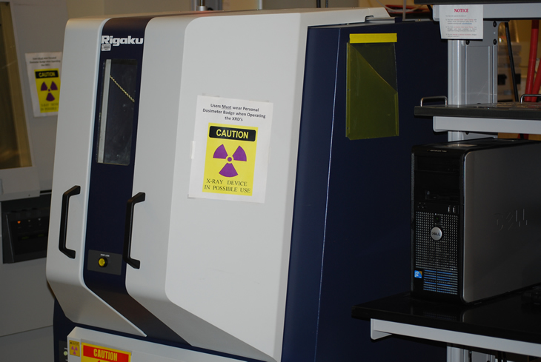
The Ultima IV represents the state-of-the-art in multipurpose X-ray diffraction (XRD) systems. Incorporating Rigaku’s patented cross beam optics (CBO) technology for permanently mounted, permanently aligned and user-selectable parallel and focusing geometries, the Ultima IV X-ray diffractometer can perform many different measurements…fast. With a multipurpose diffractometer, performance is measured by not only how fast you perform an experiment but also how fast you can switch between different types of experiments. Individual experiments are optimized with accessories like the D/teX Ultra-high-speed position sensitive detector system, but the speed between experiments is radically improved with the combination of the automated alignment and CBO.

Rigaku Supermini 200 WDXRF
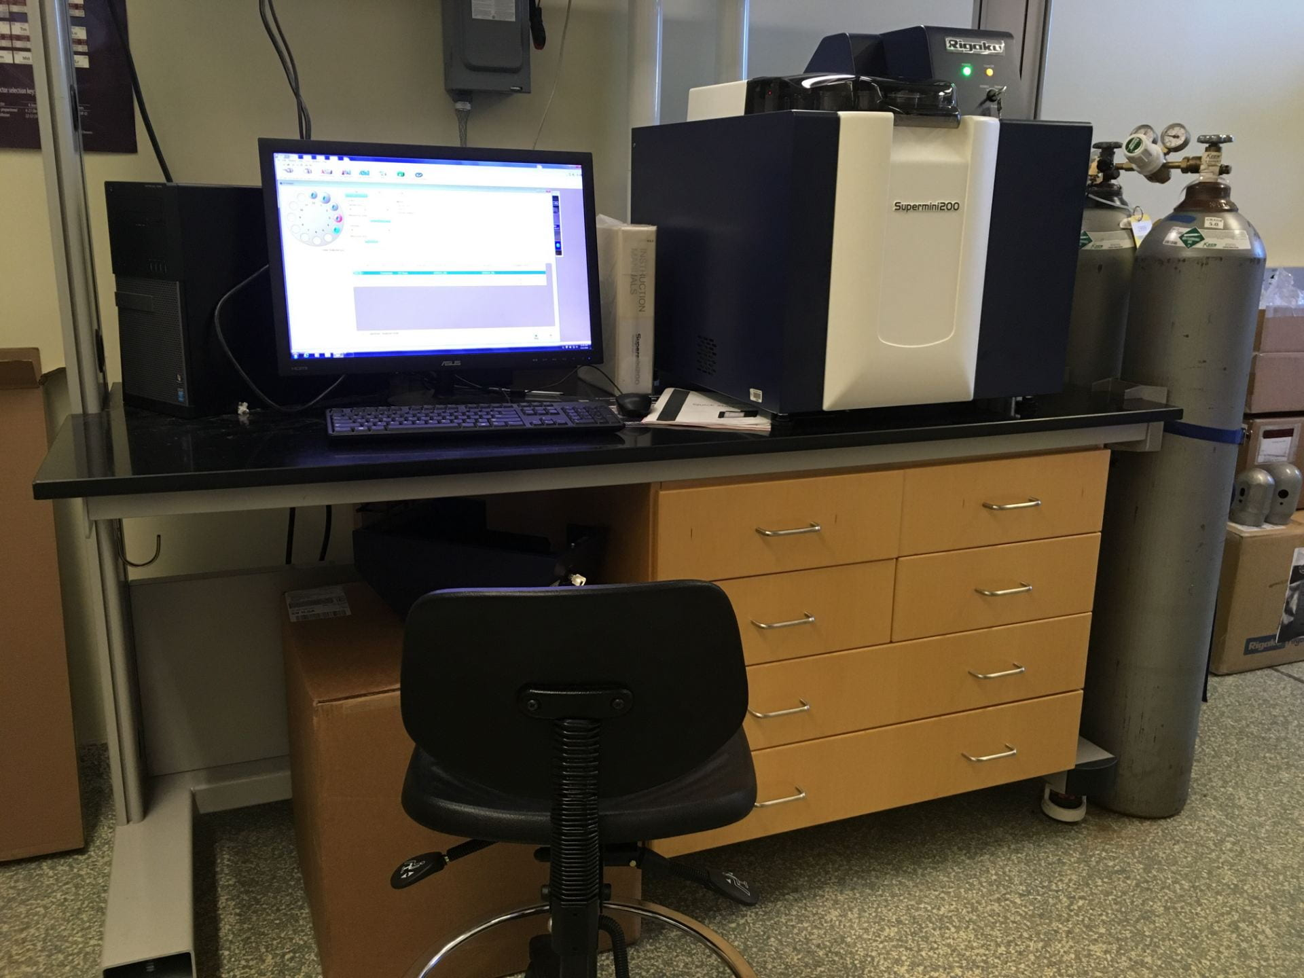
Analyzing complex matrix materials with a wide range of light and heavy elements, from trace to high concentration levels, is this instrument’s core competency. With its high powered (200 W) X-ray tube, Rigaku Supermini200 delivers high XRF sensitivity for light elements with superior spectral resolution for resolving line overlaps in complex matrices without the need for complicated mathematical peak deconvolution. Analyzing low concentration levels of light elements (F, Na, Mg, Ca, Si, Al, and P) is easy.

Xenocs SAXS/WAXS
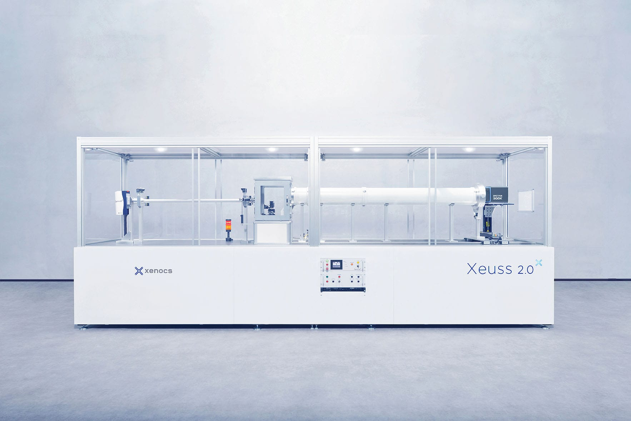

Characterize the nanostructure of soft-matter and nanomaterials using SAXS/WAXS and USAXS technique in transmission or grazing incidence mode.

– Particle size distribution ranging from few nanometers to more than 350 nm in diameter
– Crystallization rates and lamellar structure of semicrystalline polymers
– Size and shape analysis of surfactants or proteins in solutions
– Organization and orientation of nanomaterials at atomic or nanoscale, in bulk phases or at surfaces
– Phase segregation studies of alloys
– In situ studies of nanostructure transitions

Rigaku NANO 3DX CT Scanner
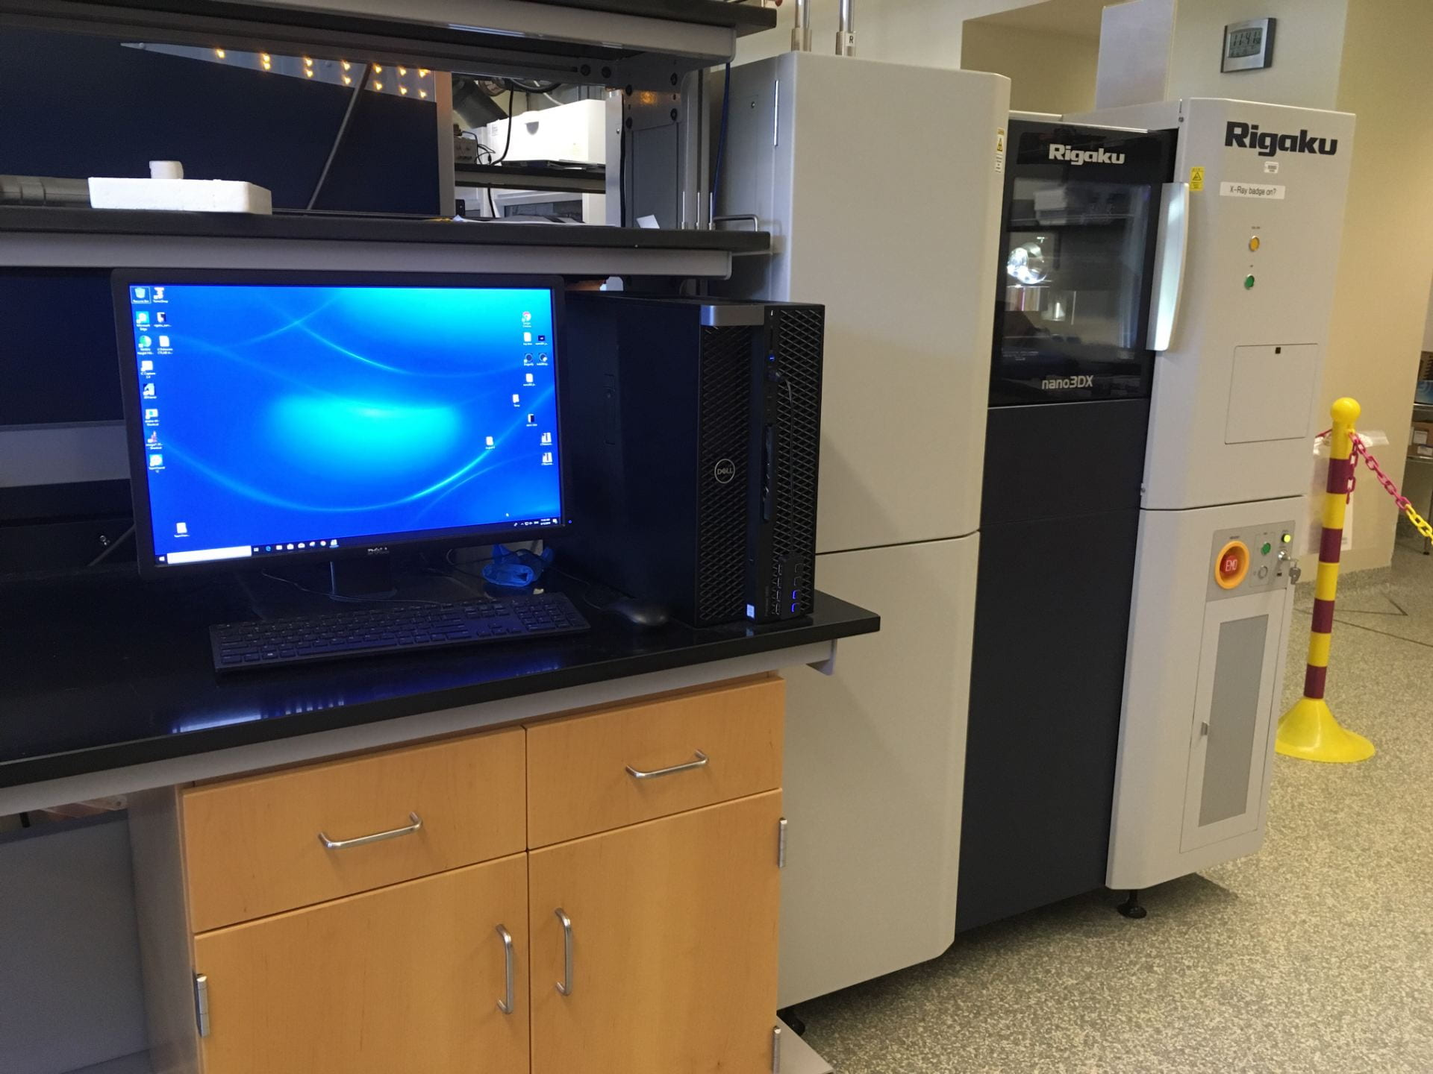
Rigaku nano3DX is a true X-ray microscope (XRM) with the ability to deliver 3D computed tomography (CT) images of relatively large samples at high resolution. This is accomplished by using a high powered rotating anode X-ray source and a high-resolution CCD detector. The rotating anode provides for fast data acquisition and the ability to switch anode materials easily to optimize contrast for specific sample types.

Rigaku GX 130 CT Scanner
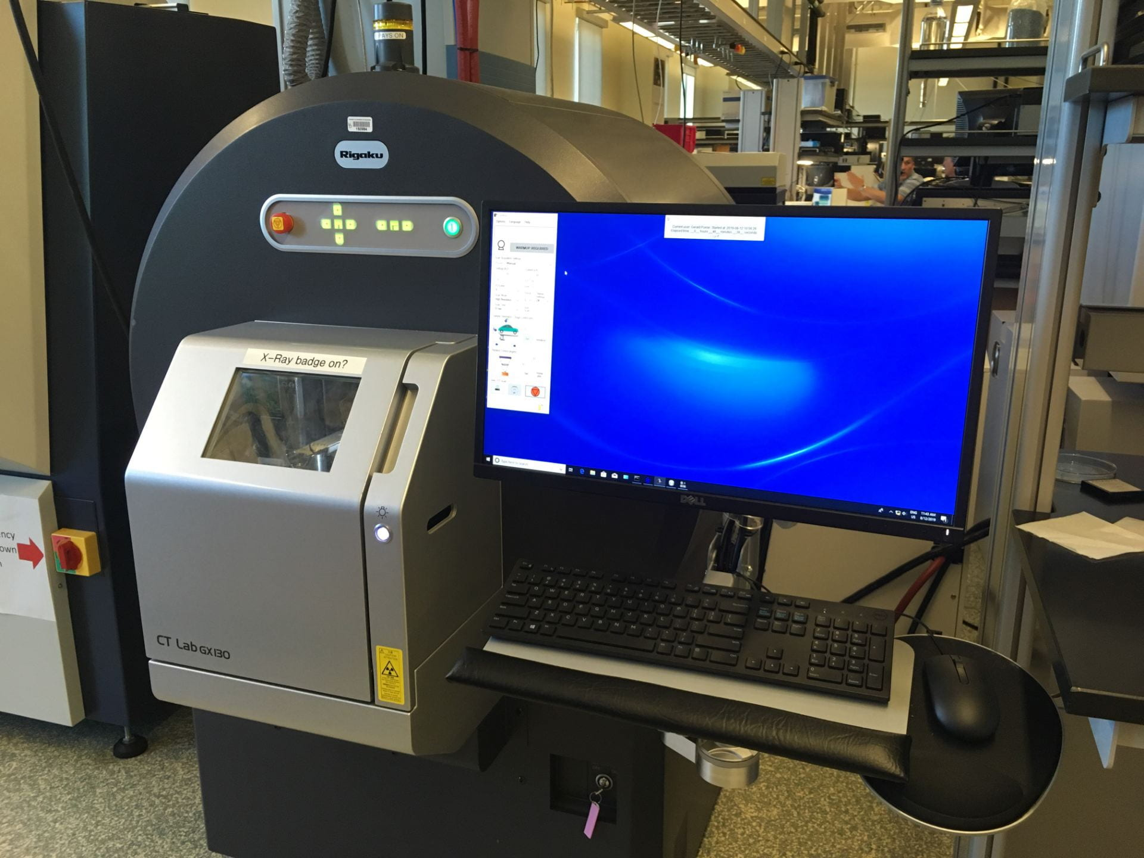
CT Lab GX 130, used for ultra-high-speed, high-resolution 3D X-ray micro CT. Using the Sample-Stationary Method, this new device can perform CT scans in 8 seconds at top speed, with a minimum resolution of 4.5 μm.

